Talent Isn’t Your Problem. Attrition Is: A Guide to Not Wasting Your Life

Conceptually, this is still true today. The vast majority of people can’t see beyond one task in front of them. They don’t have a structure of vision of what decades are supposed to look like. They just base their lives on how they feel in that particular moment: 1) graduate, 2) get some sort of job, 3) work out a little and go out to drink on weekends and 4) hop around until they decide to have kids.
Lots of cope along the way. Hit 40 with nothing to show for it, no real savings, no way to earn a living if they are cut tomorrow and pretend they are happy while talking about some politician who will save the day (they never show up)
This is the exact opposite of the lifestyle we’re trying to build up over here. The goal is to maximize whatever potential you have. No one reading this is Elon. No one reading this should be below the median either. You’re looking to: 1) regain control of your time, 2) get there without giving up your entire young adult experiences, frugality fails this hurdle and 3) get to each decade with minimal to no regrets. No matter what you will miss opportunities and make mistakes but the regret part is the real tell (better or worse).

1) Life is Primarily an Attrition Game
We talk a ton about finding your specific talent and monetizing it. The underlying reason? You’ll go up the ladder through attrition alone. In every industry people simply give up. If you’re top 5% in something at age 16, chances are everyone will quit and you’ll be top 1% by age 26.
The people who end up in the top 1%? They are a combination of both the smartest and the most consistent (decent but not world class talent): 1) continuing to grind as people quit, 2) sticking to the same process in the mind numbing boring or painful times and 3) recognizing which stage in life they are in.
If you do a quick inventory of the people around you, its easy to see all the common pitfalls and how they drop out. Typically lifestyle creep, physical burnout and the most common: despair/weak mentally.
Knowing this, step 1 is optimizing your life for minimal attrition. Create a system that you’re *certain* will work over the long term. Don’t veer from it. Compounding is heavily overestimated in a single year, and drastically underestimated over 10 years.
Note: whatever you’re making as you read this? You should be a 5-10x in 10-years if you focus all your effort on the right things (wifi money, performance based W-2 only and consistently investing in innovation long-term)

2) Three Levers to Avoid Attrition: Autonomy, Energy, Environment
If you were to boil down life into simple terms it would be Autonomy, Energy and Ecosystem. If you’re 20 years old you have a ton of Energy and little autonomy. By 40 you want to have full autonomy and an ecosystem as your energy will be significantly lower.
Since you know that Energy will decline, you have to organize the coming decades to rebalance into autonomy and your ecosystem.

1) Optimizing Autonomy
This is improved through various means: 1) wealth, 2) *how* you earn your money and 3) number of people that you would respond to at a moments notice.
Directionally that means your first goal when you have energy:
- Move from Dollar/Hour pay set up to performance based pay to a real business that is recurring and earns while you sleep
- As soon as you’re in pure performance you can ignore office politics if the numbers are good and say no to a lot of face time meetings (building your own biz on the side instead)
- Increase the number of income streams you have from various sources as fast as possible. Better to have 3 income streams of $100K each vs. one stream at $300K that can be taken to zero by one conference room meeting
“Less Risky” is a coping phrase you’ll hear from people attached to their careers. Those days are long gone with AI. Automation is only going to make wage earning harder (not easier). It makes equity owners richer (be on this side of the equation)
Note: Money is typically what people think they want in the future. However if you ask them “would you take a 20% pay cut but can work for yourself for life?”. Nearly everyone would take it in middle age. They all want freedom and autonomy

2) Energy
With high energy all parts of life are easier. You can party get up and feel fine. You can run 5 miles and have no problem pulling an all-nighter. You can perform at peak levels for a longer duration. So on and so forth.
Unless you’re going to be a professional athlete, the goal is to simply optimize for peak energy: 1) no brain fog, 2) low resting heart rate, 3) no one asks if you work out - they know you do. That’s good enough.
You’re not going to manifest your way out of biology. Everyone is going to slow down and the goal is to reduce the rate of speed without spending 10 hours a week at the gym.

3) Ecosystem
Luckily you’re here. In the regular world? It is much tougher. When you’re 40 do you want to be at the country club or still at Planet Fitness. Think that paints the picture.
Misery loves company so you should instantly avoid the unhappy and unlucky. Avoid people who talk about W-2 work all day, have no projects going on, complain about dating and watch the news. It’s all related.
Your ecosystem is doing one of two things: pulling you up or dragging you down.
There is no neutral. There is no maybe. It’s either up or down. Simple.
Go through your consistent contacts, decide which side of the fence they are on and watch as you move up the ranks through osmosis. We would wager millions that you will be dragged up if your top 5 contacts are all better than you are in the socioeconomic hierarchy. They will change the way you think and operate

3) Design in Sprints, Not Days
Most people try to “optimize their day.”
They’ll reorganize their Notion board, buy a new planner, watch productivity YouTube.
Maximum life doesn’t care about your “perfect Tuesday.”
It cares about 5-year sprints.

Design in 3-5 Year Sprints
The vast majority of people cannot do this. They need lotto tickets. They need their 16 leg parlay to hit. They cannot plan out a strategy over the course of multiple years (let alone a few months).
Inside 3-5-years? You’ll find a significant change in priorities. Look at what most 30 year olds do and compare it to 25 year olds. Even in a relatively tight window you’ll notice significant changes in priorities. It even works at 35-40 and beyond. Now you have a large neon sign saying “you’ll likely want this in the future”
Don’t multi-task. Choose one and maybe two focus items. If you’re younger shoot for two but for the majority it should be one major task. It should be big: 1) create a livable income stream online, 2) have assets cover 30% of all annual spending, 3) sell first company for over $500,000 and 4) set up trust fund for kids with no ability to touch the money.
These are all serious and large examples. That is how you should think. Big goal and big sprint.
The vast majority will cop with “balance”. The reality is the balance should be around 80/20 (like most things in life). If 80% of your real effort is spent on the primary objective, the other 20% is going to focus on random fun stuff for your age band (party, travel, golf, tennis, whatever you like)
The crux of the issue is simple. If you spend a ton of time one just one or two tasks, the compounding percentage is huge. Think of your effort as a percentage growth item in excel. Do you want it to read 20% CAGR or 80% CAGR. Put those numbers in for 5 years and you’ll get the point.
You’re not trying to face time or appear busy. You’re legitimately working. Painfully hard. On one and maybe two big projects. So you can look back in 5 years and say “this is why i’m no longer relatable to my old peer group”

4) Not Allowing Mediocrity to be Good Enough
Most people just complain. “My boss could fire me any time”. Then they login to Instagram to look at insta-models. Those models are actually AI being run by a hairy man out in Pakistan. What they are saying with their actions: “This kinda sucks but not enough for me to try”
Write out the things you don’t want to deal with and begin cutting aggressively.
- Do you want to live where you are now? If not why and what are you doing to get out of there
- How many people could have a bad day and suddenly take your paycheck to zero on an emotional outburst?
- Do you spend time thinking about people who don’t matter? Why? If a hater is obsessed with negative comments towards you what are the chances they are below you? That’s right, 100%, so start cutting
If you get trapped in a comfortable mediocre existence, the future is exactly that… forever. If something is “fine”, “good enough” or “okay”. This should be an enormous fire alarm. These phrases are only acceptable for things that don’t matter (a quick lunch), completely unacceptable as it relates to money, autonomy or personal relationships.
Each -100% deletion frees up time to compound the 1-2 task items that matter to you in your current age band.

5) Doing All This With a Quick Regret Filter
Now that you understand the major things to think about with 80% of your time and effort. What about the 20%? Making sure you don’t wake up at 35 with no life experiences beyond making money and the gym.
Think about all the things you can do in your age bracket and ask “what won’t I be able to do” and “is there anything I will regret not doing in this age band?”
The work stuff is covered. You know you’ll regret never trying to start a business. You know you’ll regret trading time for money forever. You know you’ll regret hanging out with the same people going nowhere for decades.
The soft items are harder. You will probably regret not going to party in your 20s. Do some of that. You will probably regret limited international trips in your youth. Do that as well. You will probably regret not seeing a specific concert, sports event, etc.
Bezos Goes Over This Concept In Detail

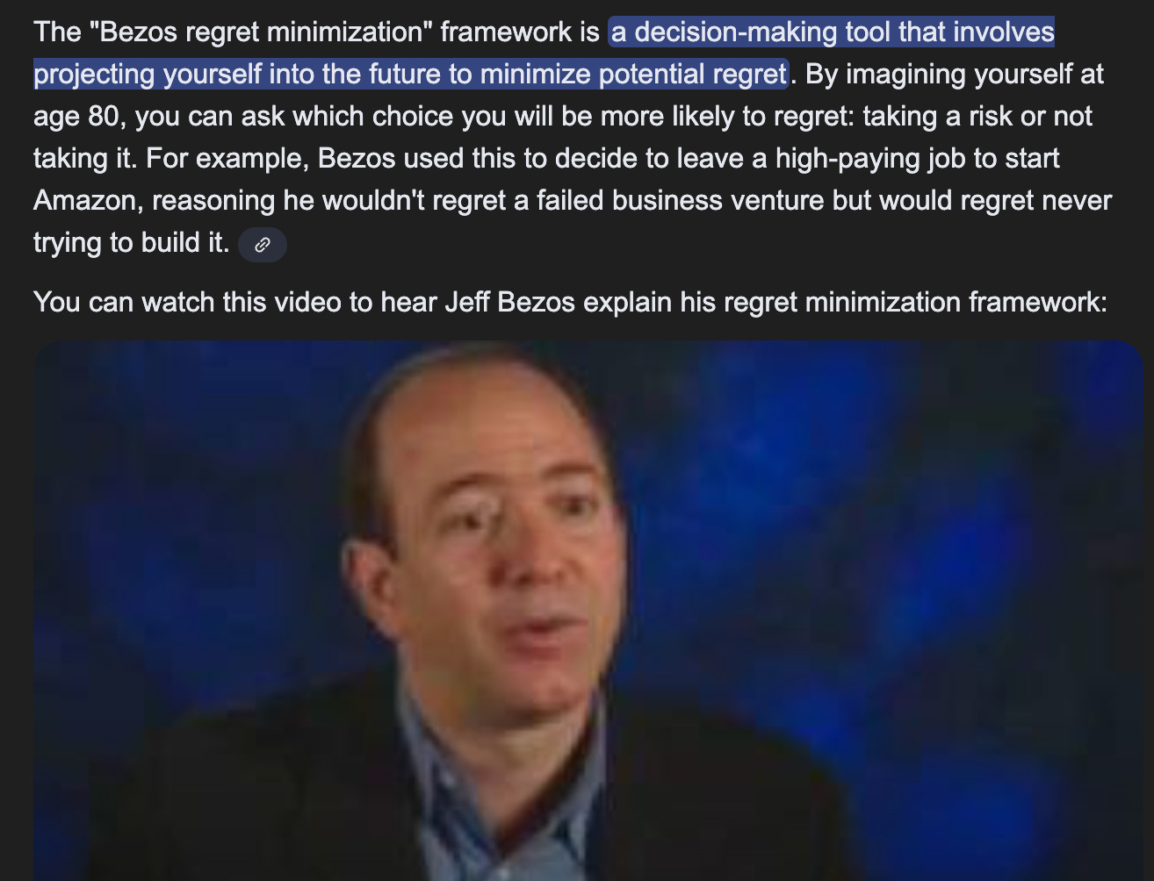

Optimize your life for minimum future regret. That is what “maximize” actually means.
Oddly, he is a perfect example of someone who didn’t party at all in his younger years. Looks like he is doing that now post retirement.

6) Repeatable Schedule and Accountability
Morning routines are viral because they don’t work. Anything the masses obsess over? Doesn’t work. Otherwise it wouldn’t be something that is popular with NPCs.
Instead its two levels of accountability and consistency. Unless you’re completely unaware of your body, you’ll already know which hours of the day are your best, your worst and medium/average.
Create *blocks* of time over the course of a full week. 80% is focused on work 20% on fitness/partying. This is a gradient (sliding scale) but we’re under the assumption someone is far behind on the WiFi Money/Wealth side. If you’re on track there you can slide the percentages a bit (health needs more effort as you age)
Everyone wants an aesthetic “morning routine.”
Four Simple Blocks of Time: 1) Intense Work Block, high effort, 2) Regular W-2 Block, medium effort, 3) Workout time, medium effort and 4) social/no effort - low energy state since none is needed.
After this you need to take out a journal once per day. You will not write some sob story dear diary in it. You will write (physical) three sentences: 1) what you did today to improve on main issue, 2) what you will do tomorrow and 3) your 3-5 year main objective and if you’re optimizing your time correctly. Needs to be a resounding yes.
These three sentences take less than a couple minutes. The value is huge though. Impossible to go to sleep every night peacefully if you write “didn’t do anything” in sentence one for more than a day. More of an Accountability Check than a Journal.

7) Life is HIIT Not Walks on the Beach
Interval training, HIIT, heavy reps and recovery? Those are all transferable to the business world as well.
You want to be going all out during your peak hours during the day. You want to turn all of that off when you’re recovering and the gains will compound faster than the United States Debt.
The majority will talk to you about work life balance and other world salad explainers for why they can’t go all out. You can 100% go all out. Just not 24/7/365.
The vast majority will never go all out once in their life. Going all out to a real breaking point will be obvious. You will be doing strange things such as: putting the milk in the microwave, trying to drink the salt shaker, putting black pepper on your fruit bowl snack. It will be obvious. If you’ve experienced this one (you will never forget it), you can now calculate the max toll your body can take (mentally). Since you know the warning signs after going to failure, you’ll know exactly how far you can press before you shut it down and go into recovery mode.
Life is non-linear. Your work effort is also non-linear. Not a coincidence.

8) Easy 5-year Jump Examples
20s: The theme is accumulation. You want to obtain new skills, relationships, muscle, etc. Build, accumulate, build, accumulate. The back burner item is without missing big life experiences: some partying and travel is necessary to be well rounded
- 20 going to 25: How do I want to earn my money long term? How will I make myself valuable enough to move into that position? Start now. Since you have no money, that cheap international trip is the go to move. No expensive condo that no one expected you to have in the first place.
- 25-30: How do I scale what I started? How do I automate by W-2 and become a performance determined employee to ditch all the politics? Combine these two wins and you’ll be flying at 30. This is the slow transition away from partying as well so get any of those events checked off!
30s: Theme here is avoid irrational exuberance. If you’ve done the work correctly, somewhere in your 30s you’re going to start feeling like a King. Hubris creeps in quickly. Despite being the most fun period of life, you should look out to 40 and realize: 1) partying is going to come to an end, 3) physically you won’t be explosive and on the rise anymore and 3) No fighting aging as you’ll look old no matter what you do in your 40s (old in this context means, “this dude shouldn’t be in night clubs” type old
- 30–35: Wealth and Personal life. Majority reading this post are focused on wealth but it doesn’t help you much if your personal life is a mess. As a rough proxy you should no longer be 80% get money mode, it should be around 50/50 with the other 50 entirely focused on what your 40s will look like. Kids, no kids, what city, what lifestyle, house, condo, etc. Don’t believe your current high lasts for 20-30+ years. “How much autonomy can I build while my energy is still pretty high?”
  - This phrase encapsulates it best, you’re now molding your income streams/wealth to fit your personal life desires. Don’t want to be asking the 55 year old if you can leave early to see your sons soccer game
- 35-40: Strange transition period. You’re old but not old. You can feel the slow down (physical/cognitive). If you don’t lock down your diet and your exercise it goes down hill quickly. This means? You’re basically transitioning into a delegator. Since you can’t squeeze more juice out of your own energy, you have to delegate a large number of tasks and grow despite having higher operating expenses. At this age band you should have zero complaints about how your life turned out. You’re a creator of systems and prioritizing personal life more and more
Age 40+: At this band you’re scaling and protecting your health. It’s that simple. Your time is more valuable since you will have drastically different priorities. Huge sea change if you decide to have kids (or not). Much larger sea change than any other decision you’ll make.
If you don’t have good systems and delegation skills, it’ll be a brutal slog of long hours and potential health issues. Best to systemize, optimize and actually spend *more* time with tech.
Oddly, your biggest risk in 40s is falling behind in the technology realm. A death sentence. Passing on bad info to your own kids and likely going out of business if you don’t stay on top of world events.

If you find yourself in-between zones that is fine. Someone who gets to $3-4M and a paid off house at 40 vs. at 44? Not really relevant. The key is to look 5 years ahead and make sure you’re dead set on what the next transition period holds.
If a 20 something lives like he is 55 (comfortable, stabile, false secure earnings), he is burning the most valuable time of his life. Time that allows for risk, compounding and life experiences. This is the underlying problem with frugality and the “FIRE” movement. Internally we all know there is something wrong about taking no risks and having no ambition at this age.

9) Done By 40.
This is the truth if you wanted to boil it down to one year and one sentence. The reality is that life is messy. Therefore we’re giving a range of 40-45 as the time frame where you want to be done. Also. It should be pretty clear if you’re on pace or not. If your goal was the standard paid off home and $3-4M liquid, and you have a paid off home and $2.5M liquid at age 40… just call it good enough. As long as you have a good income we all know you’re going to make it.
- Have one skill that you can port anywhere to generate a high income
- Have as secondary skill that can generate a living income (notice it says living income not high income. It’s rare to have two equal valued income streams. Most likely you make $240K from one and $120K from another. The $120K is livable but primarily there to hedge the $240K income stream)
- Have ownership in any business beyond real estate. Only exception to this is if you’re running a large scaled up business with 10+ properties. Meaning, a single rental would not count as a business
- Health is above and beyond good. No one asks if you work out, they know and you look good for your age
- You have no alarm clock and have complete control of your time. Or. At minimum, if a W-2 is still in the cards, you are in a performance based role and don’t have to deal with politics anymore
- Your personal life is great, you are happy with it and not complaining about it on a weekly basis
This is the quick Audit Zone. Any area lacking? If so get to that three sentence journal ASAP.

10) What Making it Actually Feels Like
For a reminder on the different types of making it, refer to this article:

While most think it is about posting up photos on instagram. It isn’t.
It simply changes your energy levels forever: 1) wake up with no stress due to no alarm clock - improves health, 2) reduces stress significantly, 3) freedom to no longer run a budget, 4) ability to choose your social interactions vs. having forced ones and 5) limited obligations
In a word, you feel like you have *control* over your life. The majority think its just smiles all the time from dopamine but it is really a sense of control. Control is a calming sensation.

Game of Attrition is Life Long
You already know that the divide is going to get bigger and bigger: 1) asset owners/operators vs. wage based earnings, 2) portable income vs. location dependent, 3) increased activity online as cost pressures move everyone to the new virtual world and 4) tech constantly doing more and more tasks that humans did in the past.
Years ago we used to worry that all the stuff we were doing and writing about would create immense competition. What we learned is the exact opposite, 99% of people do nothing. You’d think that being broke *currently* is the worst feeling in the world.
It isn’t. Being capable and wasting your life is.
Just explained why you see a lot of extremely angry and bitter middle aged men.
Don’t be another talented casualty.

